**Practical 7**

a. Perform Simple Linear Regression on the data set Salary_Data.csv.

## **Step 1: Import the required python packages**

# Import libraries  
import pandas as pd

import numpy as np

import matplotlib.pyplot as plt

import seaborn as sns

from sklearn.model_selection import train_test_split

from pandas.core.common import random_state

from sklearn.linear_model import LinearRegression

## **Step 2: Load the dataset**

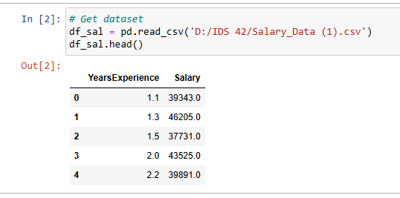

## **Step 3: Data analysis**

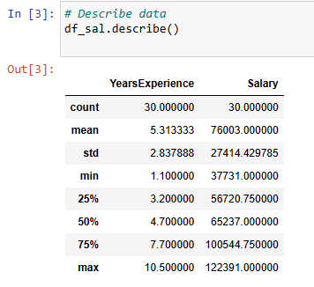

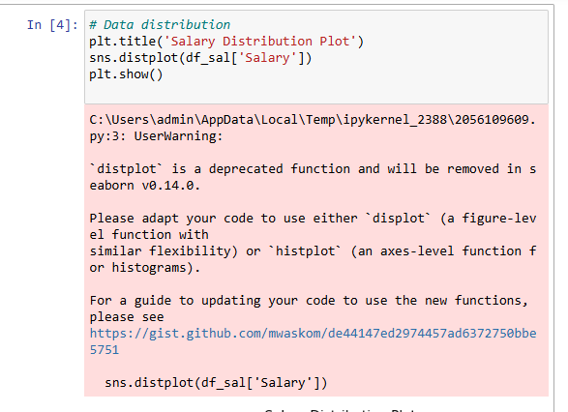

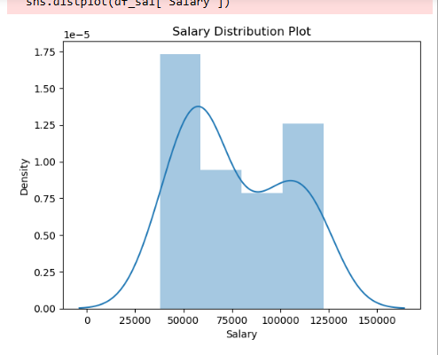

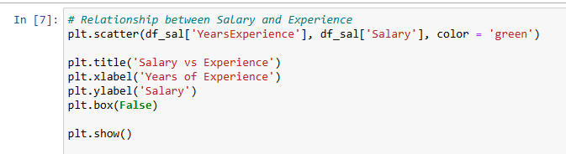

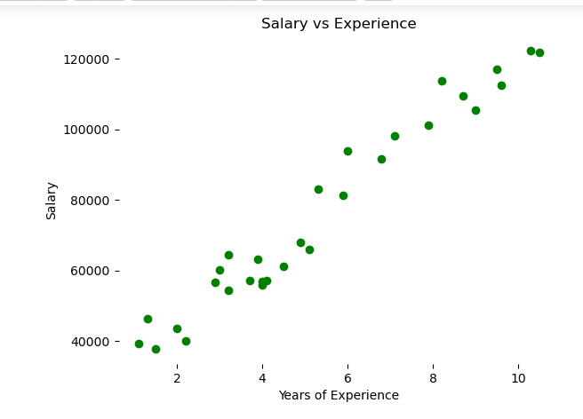

**Step 4: Split the dataset into dependent/independent variables**

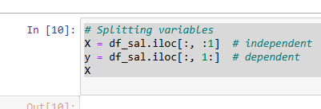

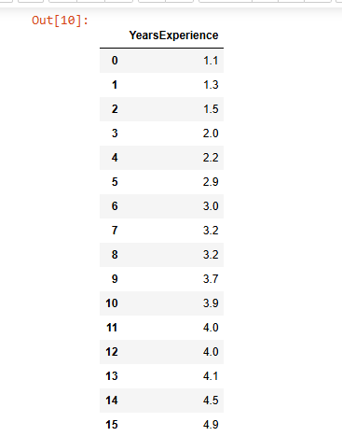

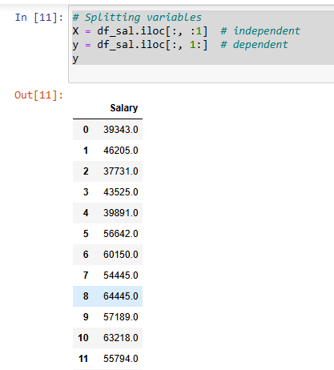

## **Step 4: Split data into Train/Test sets**



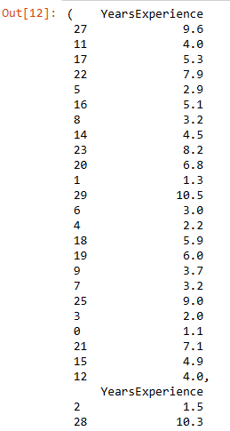

## **Step 5: Train the regression model**

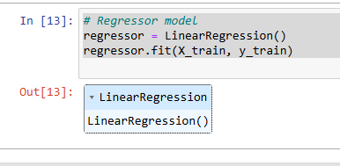

## **Step 6: Predict the result**

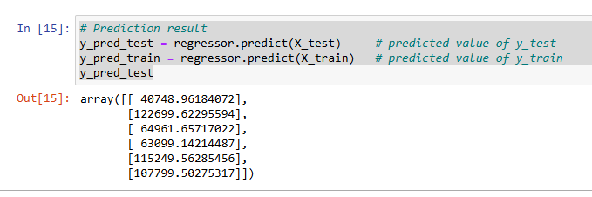

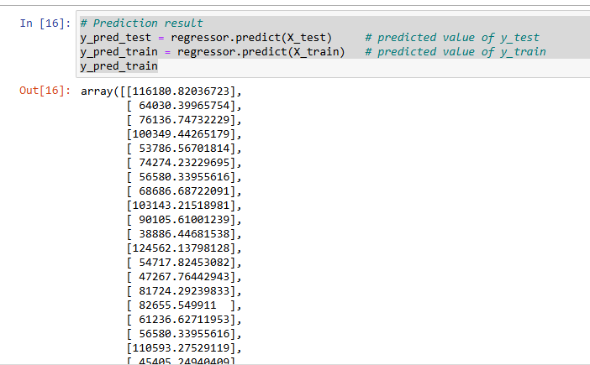

## **Step 7: Plot the training and test results**

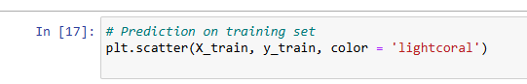

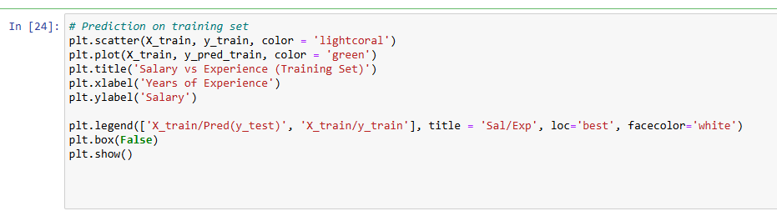

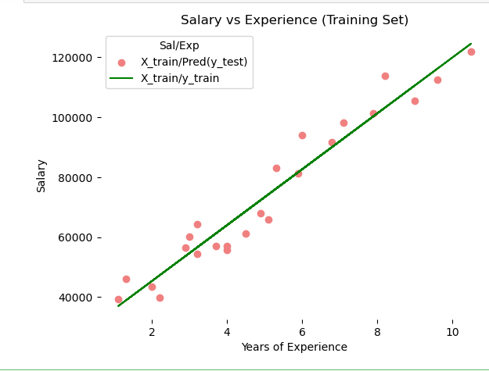

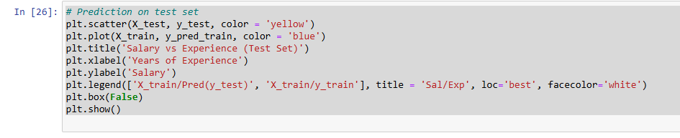

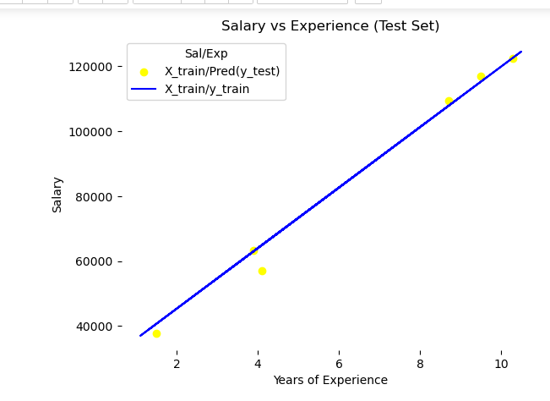

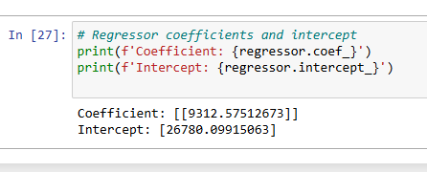

**Testing Accuracy of the Model**

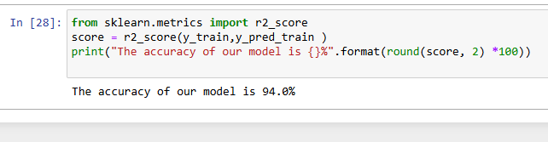

b. .Perform Multiple Linear Regression on the data set Advertising.csv.

**Importing the Libraries**

import pandas as pd

import numpy as np

import matplotlib.pyplot as plt

import seaborn as sns

**Reading the Dataset**

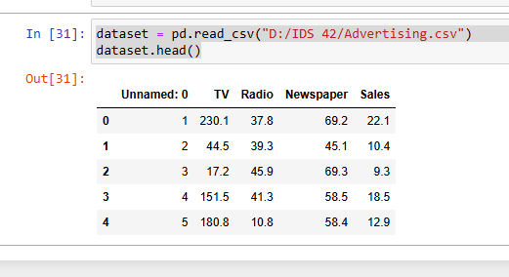

**Setting the values for independent (X) variable and dependent (Y) variable**

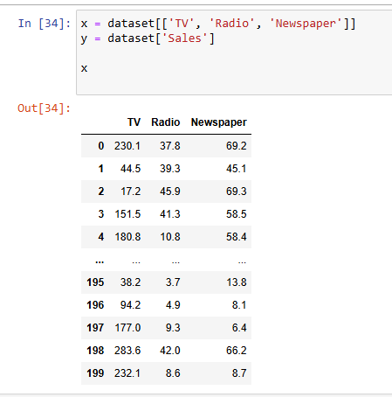

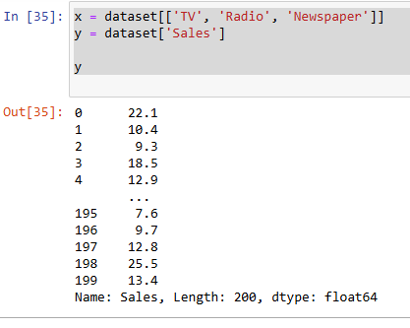

**Splitting the dataset into train and test set**

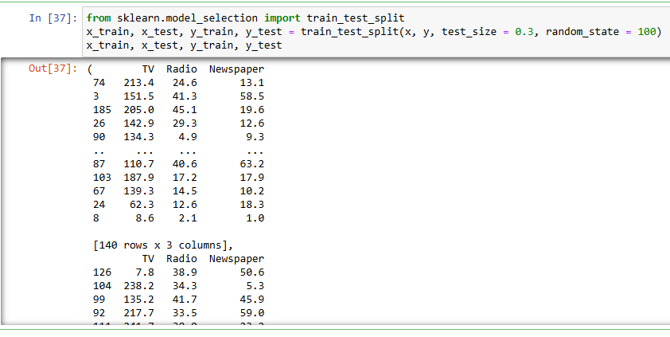

**Implementing the linear model**

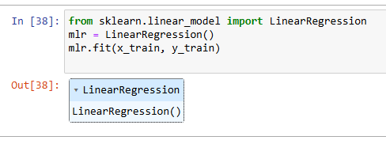

**Model Equation**

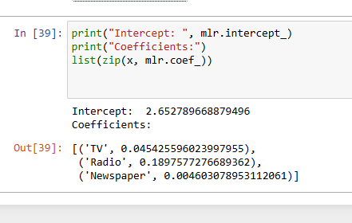

**Prediction on the test set**

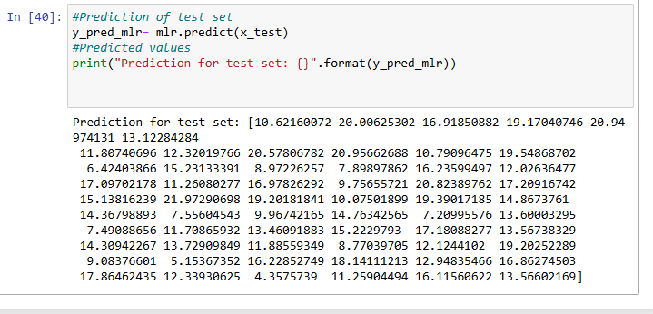

**Actual values and the predicted values**

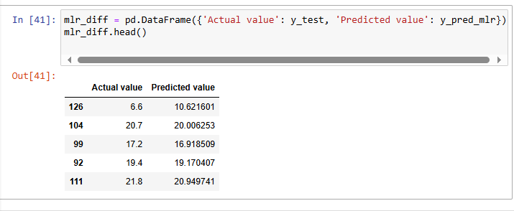

**Evaluating the Model**

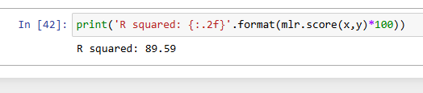

Name : Cheruvathoor Abin Anto

Roll No : TIT2425008

**Practical 8 :** **K-means clustering in Action using Python**

**Import libraries and load the data**

import pandas as pd

import matplotlib.pyplot as plt

from sklearn.cluster import KMeans

# load the customer data into a DataFrame

customer_df = pd.read_csv('D:/Aby/IDS/Mall_Customers.csv')

# Check the first 5 rows

customer_df.head()

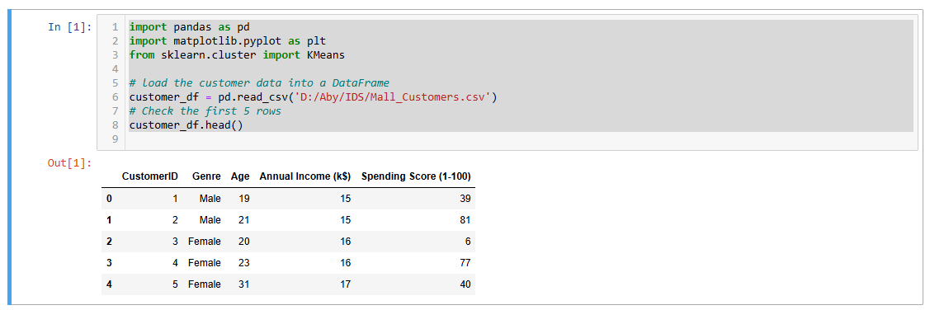

**Explore the data**

plt.scatter(customer_df["Age"],

customer_df["Spending Score (1-100)"])

plt.xlabel("Age")

plt.ylabel("Spending Score (1-100)")

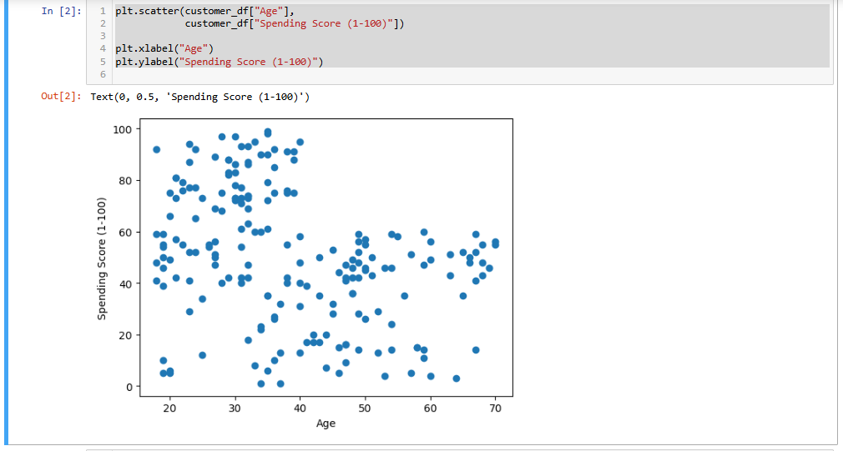

plt.scatter(customer_df["Age"],

customer_df["Annual Income (k$)"])

plt.xlabel("Age")

plt.ylabel("Annual Income (k$)")

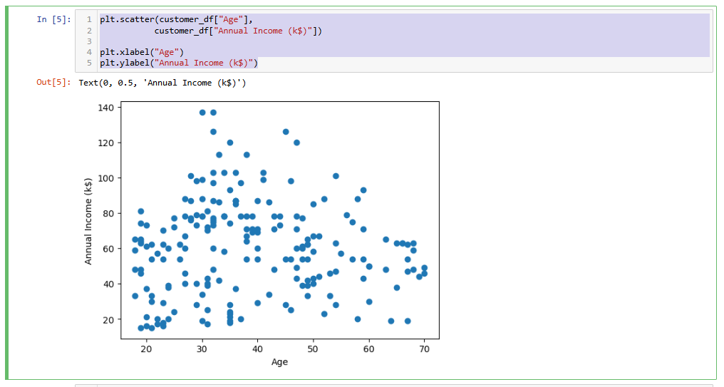

plt.scatter(customer_df["Spending Score (1-100)"],

customer_df["Annual Income (k$)"])

plt.xlabel("Spending Score (1-100)")

plt.ylabel("Annual Income (k$)")

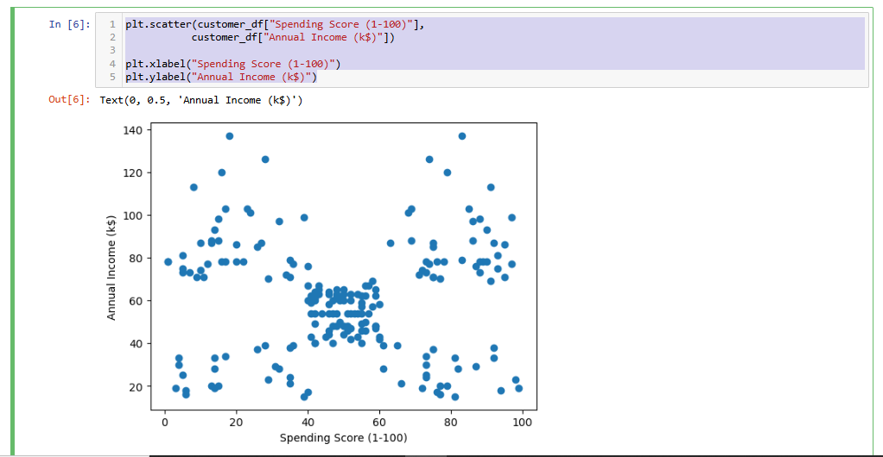

customer_df.isnull().sum()

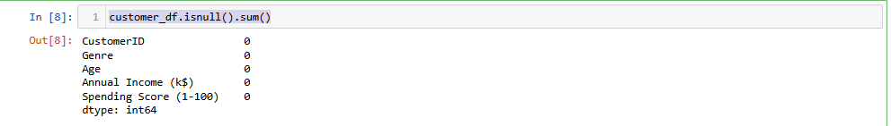

**Get the relevant columns for clustering**

relevant_cols = ["Age","Annual Income (k$)","Spending Score (1-100)"]

customer_df = customer_df[relevant_cols]

**Data Transformation**

from sklearn.preprocessing import StandardScaler

scaler = StandardScaler()

scaler.fit(customer_df)

scaled_data = scaler.transform(customer_df)

**Determine the best number of cluster**

Below is the code for the first function:

def find_best_clusters(df, maximum_K):

clusters_centers = []

k_values = []

for k in range(1, maximum_K):

kmeans_model = KMeans(n_clusters = k)

kmeans_model.fit(df)

clusters_centers.append(kmeans_model.inertia_)

k_values.append(k)

return clusters_centers, k_values

**The second function uses those inertias and K values to generate the final Elbow plot.**

def generate_elbow_plot(clusters_centers, k_values):

figure = plt.subplots(figsize = (12, 6))

plt.plot(k_values, clusters_centers, 'o-', color = 'orange')

plt.xlabel("Number of Clusters (K)")

plt.ylabel("Cluster Inertia")

plt.title("Elbow Plot of KMeans")

plt.show()

**Now, we can apply the above 2 functions to the dataset using a maximum K value of 12 and get the final result.**

clusters_centers, k_values = find_best_clusters(scaled_data, 12)

generate_elbow_plot(clusters_centers, k_values)

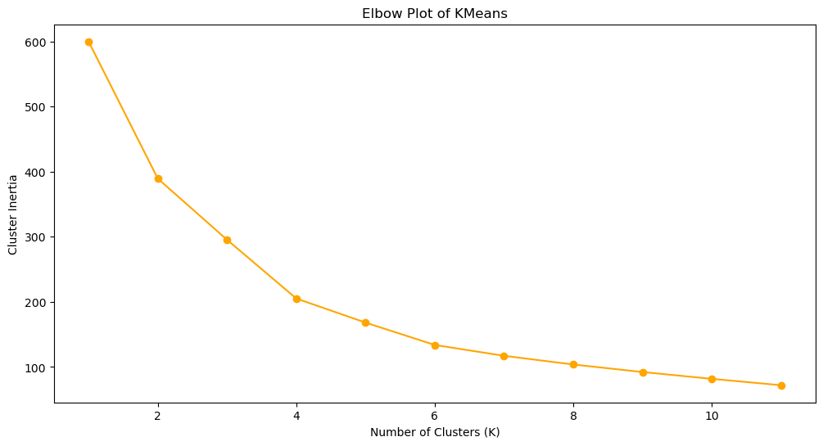

**Create the final KMeans model**

kmeans_model = KMeans(n_clusters = 5)

kmeans_model.fit(scaled_data)

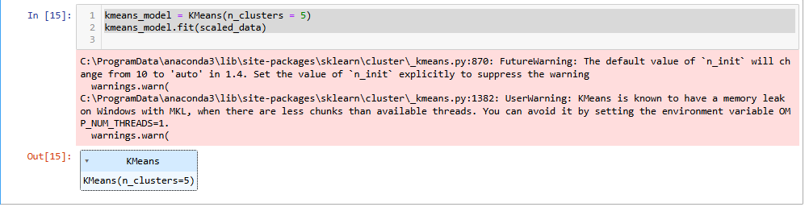

**The .fit() method is used to train the K-Means clustering model on the given dataset (scaled_data).**

customer_df["clusters"] = kmeans_model.labels_

customer_df.head()

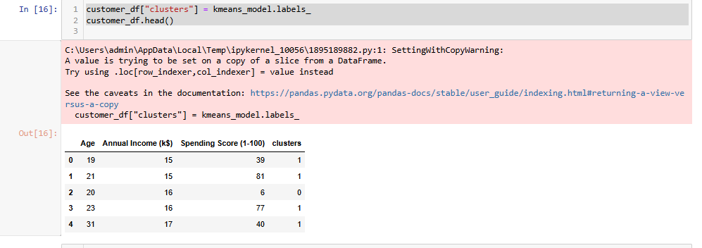

**Visualize the clusters**

plt.scatter(customer_df["Spending Score (1-100)"],

customer_df["Annual Income (k$)"],

c = customer_df["clusters"])

plt.xlabel("Spending Score (1-100)")

plt.ylabel("Annual Income (k$)")

